# B39SB Time and Frequency Signal Analysis – Tutorial 3

**P1.** Let x(t) be a signal with Nyquist rate ω0. In other words, X(ω0), the Fourier transform of x(t), vanishes when |ω|> ω0/2. Determine the Nyquist rates for the following signals:



Solution:



The Nyquist rate is the same as for x(t).



The Nyquist rate is the same as for x(t).



Y(ω) vanishes when |ω|> ω0 + ω0/2. The Nyquist rate is 3ω0.



Y(ω) vanishes when |ω|> ω0. The Nyquist rate is 2ω0.

**P2.** Find the Laplace transform X(s) and sketch the pole-zero diagram with the ROC for the following signals *x*(*t*):



Solution:

(a)





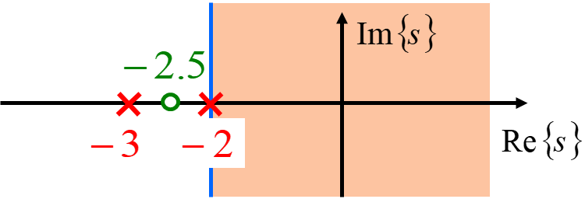

(b)





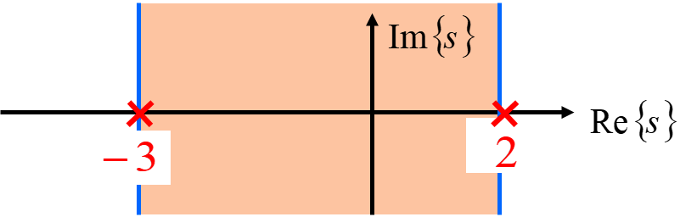

(c)





The ROCs do not overlap and, therefore, there is no common ROC. Thus *x*(*t*) has no Laplace transform.

**P3.** Find the inverse Laplace transform of the following X(s).



Solution:

(a)







(b)







(c)







**P4.** In a continuous-time LTI system the input x(t) and output y(t) are related by



(a) Find the system function H(s).

(b) Determine the impulse response h(t) for each of the following three cases:

(i) the system is causal

(ii) the system is stable

(iii) the system is neither causal nor stable.

Solution:

(a)



(b)





